DAA Lab Assignment-04
1)Write a program to sort the array elements using Merge Sort Technique. Derive its time complexity
ANS: #include <stdio.h>
#include <stdlib.h>
void merge(int arr[], int left, int mid, int right)
{
int i, j, k;
int n1 = mid - left + 1;
int n2 = right - mid;
int leftarr[n1], rightarr[n2];
for (i = 0; i < n1; i++)
{

leftarr[i] = arr[left + i];
}
for (j = 0; j < n2; j++)
{
rightarr[j] = arr[mid + 1 + j];
}
i = 0;
j = 0;
k = left;
while (i < n1 && j < n2)
{
if (leftarr[i] <= rightarr[j])
{
arr[k] = leftarr[i];
i++;
}
else
{
arr[k] = rightarr[j];
j++;
}
k++;
}

while (i < n1)
{
arr[k] = leftarr[i];
i++;
k++;
}

while (j < n2)
{
arr[k] = rightarr[j];
j++;
k++;
}
}

void mergeSort(int arr[], int left, int right)
{
if (left < right)
{
int mid = left + (right - left) / 2;
mergeSort(arr, left, mid);
mergeSort(arr, mid + 1, right);
merge(arr, left, mid, right);
}
}

int main()
{
int arr[] = { 36,80,14,42,6,72,40 };
int n = sizeof(arr) / sizeof(arr[0]);
mergeSort(arr, 0, n - 1);
for (int i = 0; i < n; i++)
{
printf("%d ", arr[i]);
}
return 0;
}
Time complexity:O(nlogn)
Space complexity:O(n)
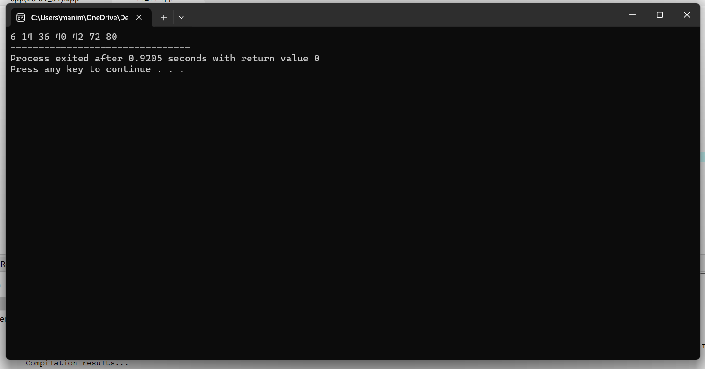
2. Write a program to sort the array elements using Bucket Sort Technique.
Derive its time complexity
ANS: #include <stdio.h>
#include <stdlib.h>

void bucketsort(float arr[], int n)
{
float max_val = arr[0];
for (int i = 1; i < n; i++)
{
if (arr[i] > max_val)
max_val = arr[i];
}

float norm_arr[n];
for (int i = 0; i < n; i++)
{
norm_arr[i] = arr[i] / max_val;
}

float buckets[n][n];
int bucketcount[n];
for (int i = 0; i < n; i++)
{
bucketcount[i] = 0;
}

for (int i = 0; i < n; i++)
{
int bucketindex = (int)(n * norm_arr[i]);
if (bucketindex == n) bucketindex = n - 1;
buckets[bucketindex][bucketcount[bucketindex]++] = norm_arr[i];
}

for (int i = 0; i < n; i++)
{
for (int j = 1; j < bucketcount[i]; j++)
{
float key = buckets[i][j];
int k = j - 1;
while (k >= 0 && buckets[i][k] > key)
{
buckets[i][k + 1] = buckets[i][k];
k--;
}
buckets[i][k + 1] = key;
}
}

int index = 0;
for (int i = 0; i < n; i++)
{
for (int j = 0; j < bucketcount[i]; j++)
{

arr[index++] = buckets[i][j] * max_val;
}
}
}

int main()
{
float arr[] = {2,6.57,44,3.78,12,1.87,5,8.32,9};
int n = sizeof(arr) / sizeof(arr[0]);

printf("Original array: ");
for (int i = 0; i < n; i++)
{
printf("%.2f ", arr[i]);
}
printf("\n");

bucketsort(arr, n);

printf("Sorted array: ");
for (int i = 0; i < n; i++)
{
printf("%.2f ", arr[i]);
}
printf("\n");

return 0;
}
Time complexity:O(n^2)
Space complexity:O(n+k)
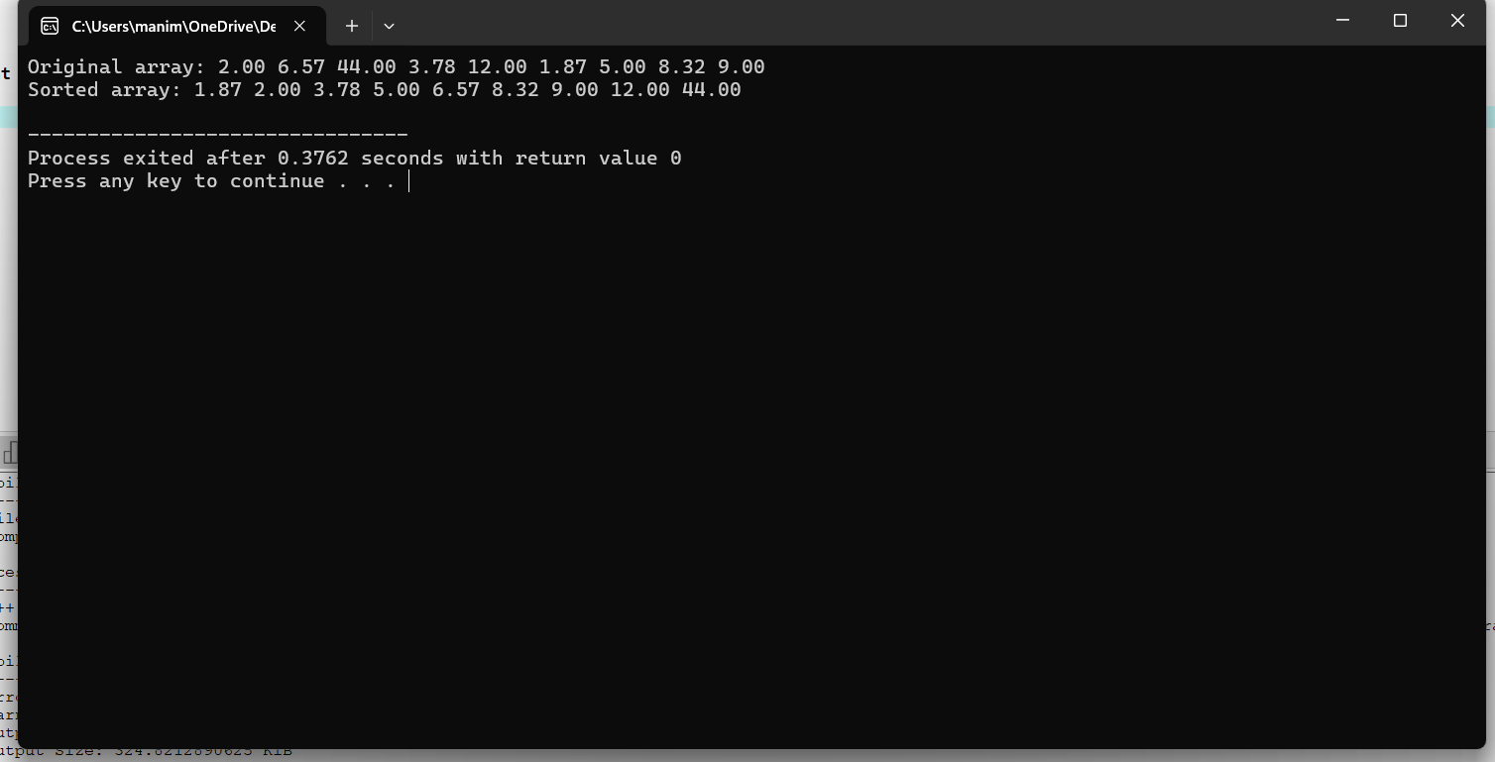

3. Write a program to sort the array elements using Quick Sort Technique.Derive its time complexity
ANS :#include<stdio.h>
void quicksort(int a[],int left,int right)
{
if(left>=right)return;
int pivot=a[right];
int i=left,j;
for(j=left;j<right;j++)
{
if(a[j]<pivot)
{
int temp=a[i];
a[i]=a[j];
a[j]=temp;
i++;
}
}
int temp=a[i];
a[i]=a[right];
a[right]=temp;
quicksort(a,left,i-1);
quicksort(a,i+1,right);

}
int main()
{
int a[]={2,66,5,47,35,88,9,18};
int n= sizeof(a)/sizeof(a[0]);
int i;
quicksort(a,0,n-1);
printf("sorted array: ");
for(i=0;i<n;i++)
{
printf("%d ",a[i]);
}
return 0;
}
Time complexity:O(n^2)
Space complexity:O(n)
